**Brass & Mirror Swallow Wall Decoration**

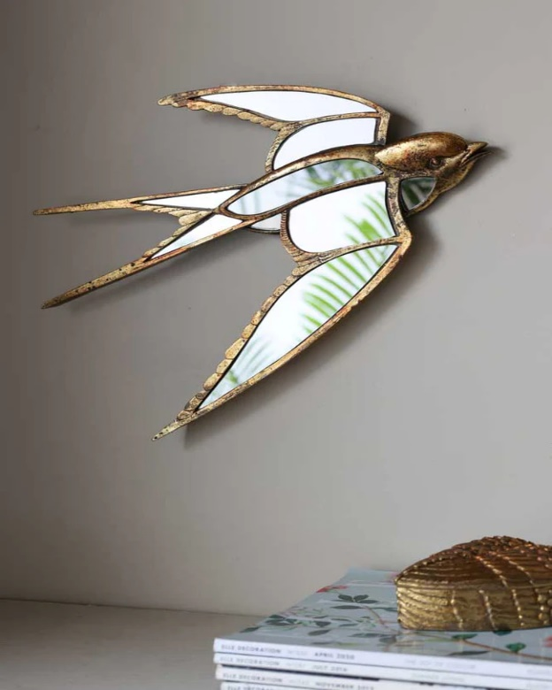The **Brass & Mirror Swallow Wall Decoration** is a striking piece that combines elegance with a touch of whimsy. Featuring beautifully crafted brass swallows in flight, this decorative item integrates the natural beauty of birds with the sleek sophistication of mirrors. The reflective surface enhances the design, creating a sense of depth and movement as the swallows appear to soar across your wall. Perfect for adding a stylish focal point to living rooms, entryways, or bedrooms, this wall decoration brings a unique blend of modern luxury and nature-inspired charm to any space.